How to do verification for Paper side.

1. Ask for JEF/SOW and read changes/business rules
2. Ask AC/IS for templates from client
3. Ask AC/IS for samples approval (Yes/No)
4. In request for QA from developers should content follow info: Name of project, that need to verify with CID and JID (Exmp: FFDMDL067), parallel ID, or all files that was changed, .dfa project should be exported to qa folder.
5. Import dfa project, looking for changes. Do a diff in UNIX for understand what was changed, if see more changes then in .dfa file –ask developer about it.
6. Depends from changes review the project. Note mismatch. If we have a new text, logo, signature, etc, load old .dfa file and open in designer for comparing.
7. If not a new app- do diff for comparing qa and production files, see what a diff.

EXMP: [larisaR@rhs control]$ diff /home/test/control/sheldla.control /home/control

41c41

< e_automate="e4"

---

> #e_automate="e4"

44,46c44

< #infotrac='m'

< #track_by_rec="y"

< #estmt_trac="y"

---

> infotrac='m'

75c73

< export dir procdate fn sam_jid cover_ovl supprefix e_automate

---

> export dir procdate fn sam_jid cover_ovl supprefix

[larisaR@rhs control]$

1. If a new app, or going as a new, follow SOW and verify everything is match with SOW: in control file: verify: all papers/Env/BRE (inserts), Endorsement type (R or A), mail_full_serv (ASE1-use for both CA and TX; ASE-3 for Full mail tracking only) if state ‘texas=y’ means –printing in TX. Verify heavy, ‘STMTC1’ will work only if we have Pre-print
2. Check paper/Env size and # with Control list.

|  |  |  |  |  |  |  |  |
| --- | --- | --- | --- | --- | --- | --- | --- |
| **Letter – Daily Notices** | | | | | | | |
| **Paper Tray Assignment** | | | | | | | |
| Tray 1 | | Tray 2 | | Tray 3 | | Tray 4 | |
| 4000 | | N/A | | N/A | | N/A | |
| **Insert Bin Assignment** | | | | | | | |
| Bin 1 | Bin 2 | | Bin 3 | | Bin 4 | | Bin 5 |
| N/A | N/A | | N/A | | N/A | | N/A |
| **Envelope Assignment** | | | | | | | |
| Envelope 1 | | Envelope 2 | | Envelope 3 | | Envelope 4 | |
| 4401 | | 4401 | | 4402 | | 4411 | |

1. Check BR in SOW on ‘grouping’: Here we need to make sure we have a group file created by programmer (check in UNIX)
2. Double anchor if it a PRINT IMAGE we should verify on Double anchors our app- modify and test data file to avoid ‘double nesting’.
3. Verify: mail code in the .dfa on “Hold mail”, “Do not print” etc –see SOW rules for that.

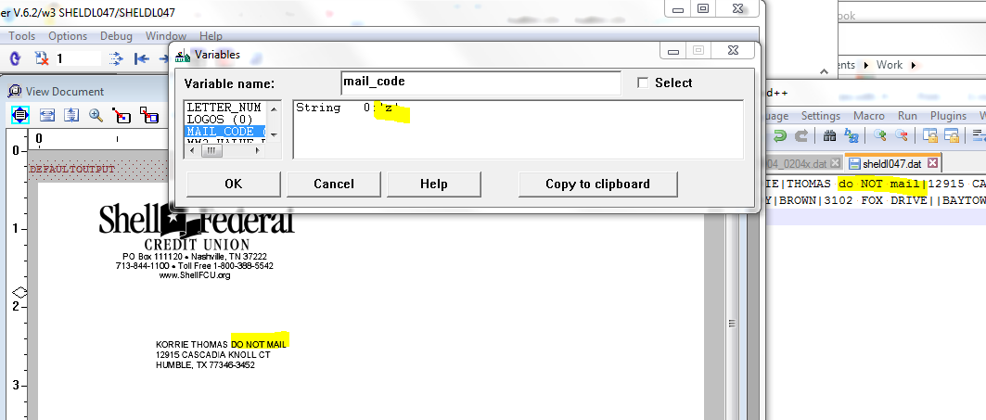

1. Verify .process file in master directory for file name matching, note on encryption.
2. Verify app VID and APP #s in the DataTrac web.
3. Verify simplex/duplex pages
4. Verify data file matching with output, do test-manipulation for data file and see an issue.
5. Follow rules with masking accounts, remittances, inserts, suppressions, material specifications, MICR line (if applicable)
6. If it’s a New app, need to do Tap test, check what type of Env we use and do tap test.
7. Create pdf –verify if everything on right place
8. Generate a file and verify data with generated file for correct size of images, simplex/duplex, inserts, and last account should generated correctly.

**Use our web sites below for work and verifying:**

<http://etaboard.infoimage.com/prod/login.php>

<http://sharepoint-svr/AS/Shared%20Documents/Forms/AllItems.aspx?RootFolder=%2fAS%2fShared%20Documents%2fSOW%20Directory%2fEECU%20-%20Evolve%20CU&FolderCTID=&View=%7bE7AC7355-889B-41DB-897F-EA690A6CE437%7d> share point in MS

<http://msgps/is/searchJobType.htm> - DataTrac

[https://track.infoimageinc.com/](https://track.infoimageinc.com/%20%20)  - issues/JEFs